Dear Families,  We had a great start to our preschool year!! The children are beginning to learn the school routine and rules of the classroom. The first 2 weeks the children will be learning all about school (how to use tools appropriately, where everything belongs).  We are also learning all of our new friend’s names; ask your child to name some of his/her new friends. The children had a lot of fun helping to make play dough and rainbow rice for the classroom.  In the month of September we will continue to get to know each other as we learn about our friends and ourselves with our All About Me unit. Some of the Ohio Early Learning Content Standards for the All About Me unit include:  Topic: Awareness and Expression of Emotion  -Recognize and identify own emotions and the emotions of others.  -Communicate a range of emotions in socially acceptable ways.  Topic: Self-Concept  -Identify the diversity in human characteristics and how people are similar and different  -Compare own characteristics to those of others  Topic: Interactions with Adults  -Engage in extended, reciprocal conversations with familiar adults.  -Request and accept guidance from familiar adults | September Family Project:  Every month we will have a family project for your child to complete with your family. This month’s project is called Family Scrapbook. On Monday September 15th directions will be sent home for this project. Please start collecting 3 pictures of your family engaged in activities that you enjoy (ex. going to the beach, playing outside, going camping, playing games, etc.) This project will be due on Monday September 29th. The children will share their projects with their classmates.  Reminders/New Information  *We will have gross motor/gym class on Tuesdays, please make sure your child wears tennis shoes.  * Thank you to everyone who brought in their supplies and extra set of clothing; also for sending in your blue cards, food permission slips and policy forms. If you have not done this yet, please do so. Also remember to label everything.  *We will begin to learn about an alphabet letter each week beginning on Monday September 15th. The children will be introduced to the upper and lowercase letter, the sound of the letter and how to write it. Each child will work on what is developmentally appropriate for their age and/or ability level.

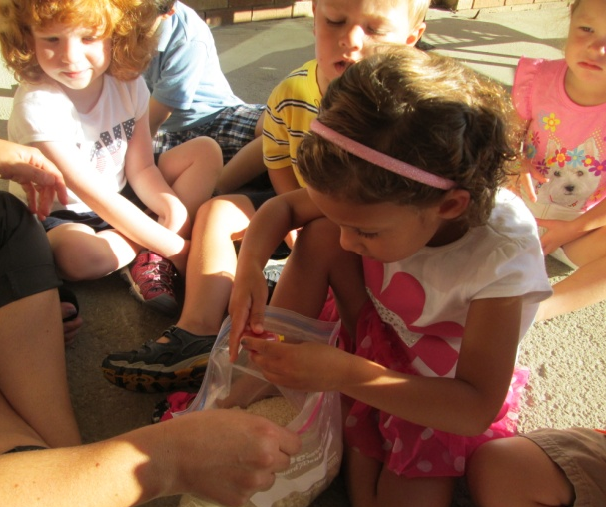
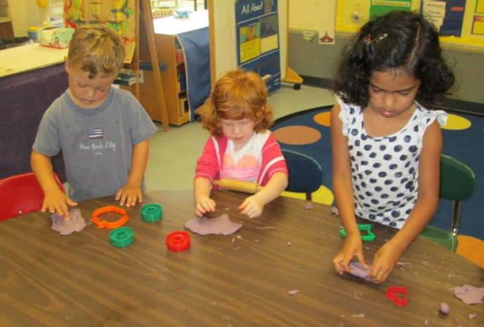
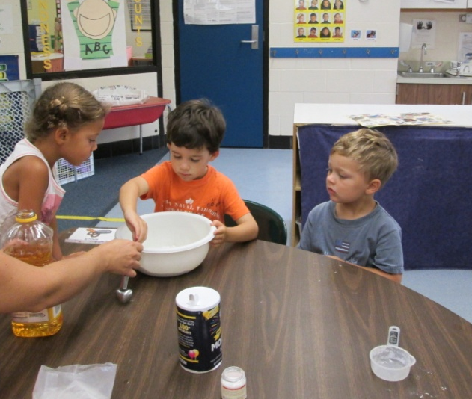
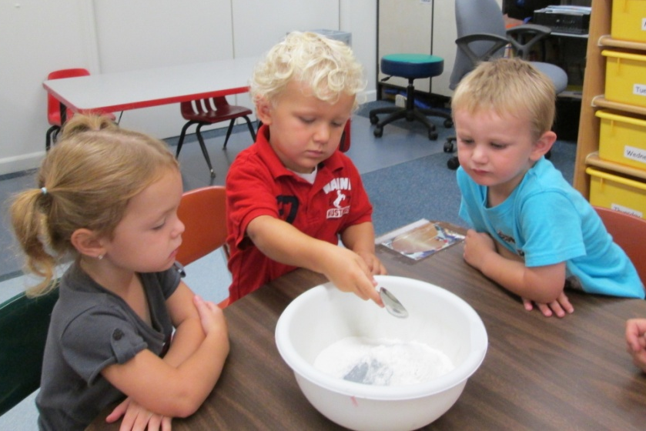
Making Playdough & Rainbow Rice for the Classroom

